**Ex: Creation of Calculator in Java Netbeans**

**Steps:**

1. Open File->New Project->Java->Java Application->Click Next

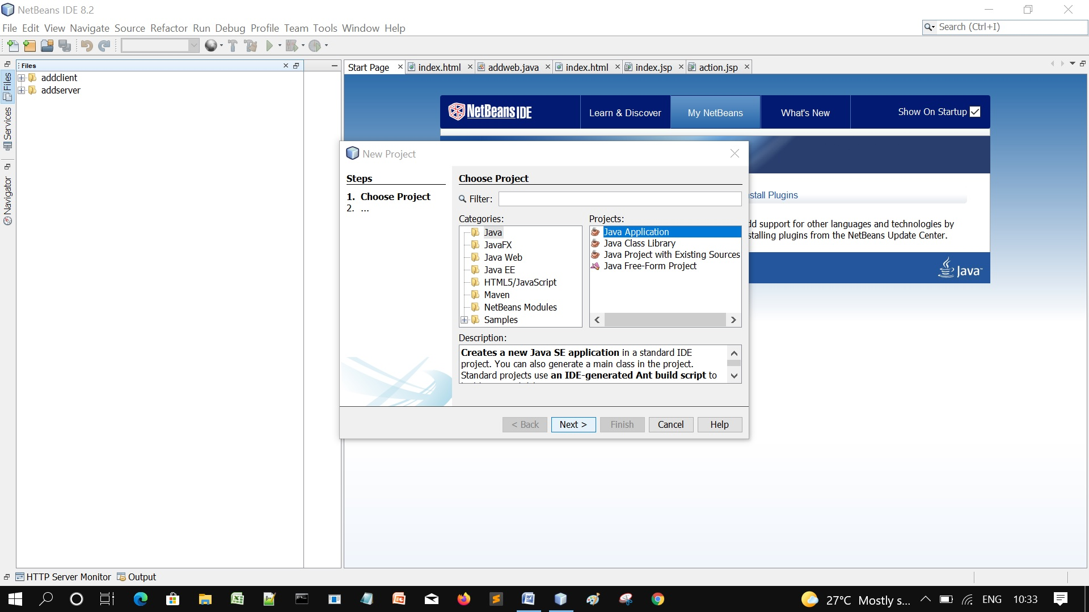

2. Give Project name-> then Click Finish

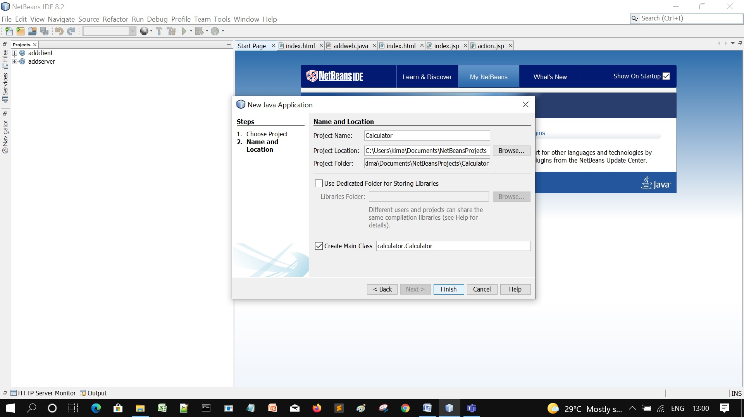

3. The Calculator project will be created. Right click on it-> New-> JFrame Form

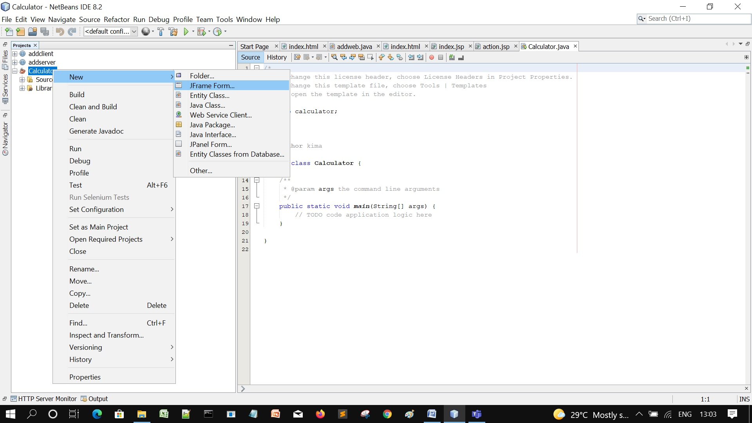

4. Give the Class Name and Package Name and then Click Finish

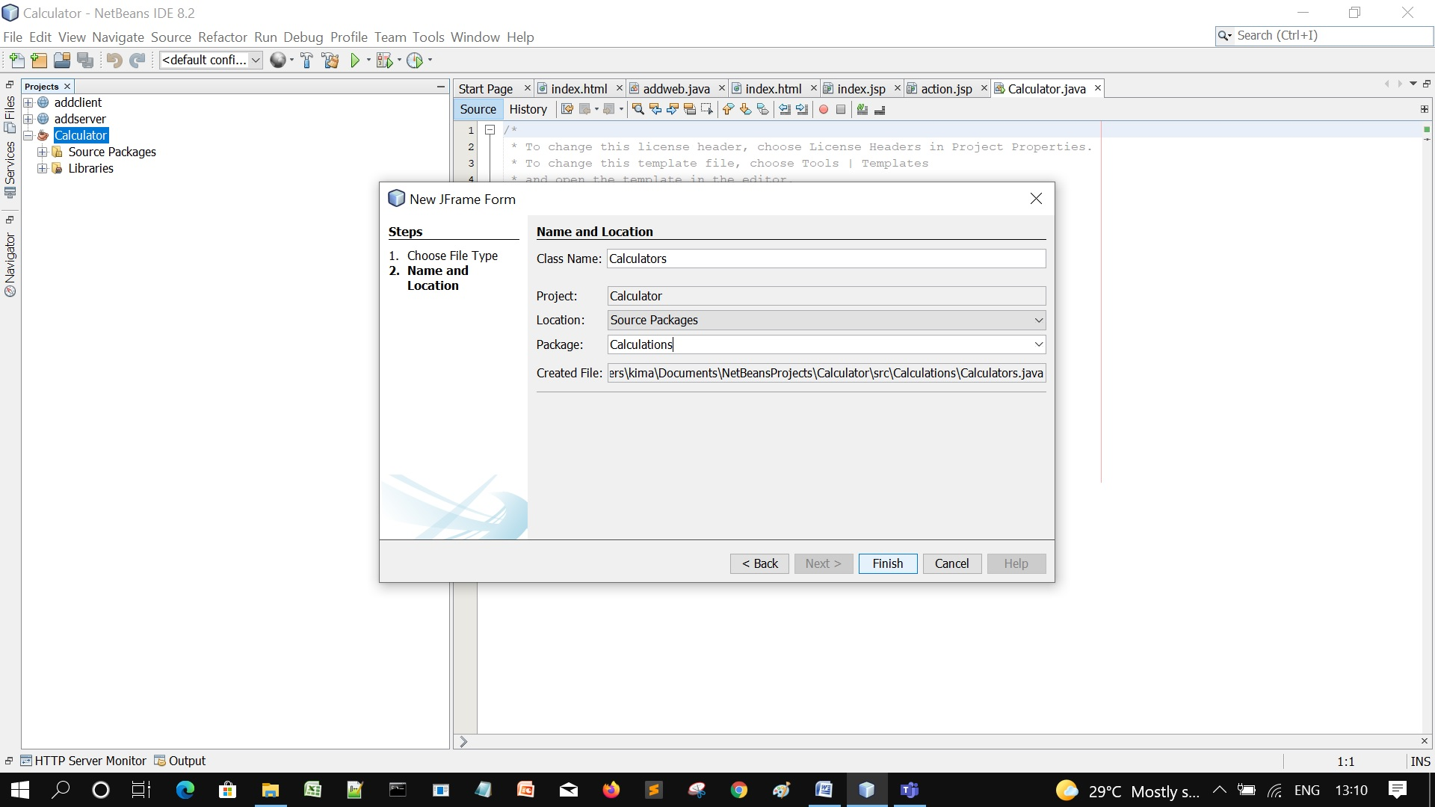

5. Now in the Palette section, Click on Text Field and drag towards Design Frame

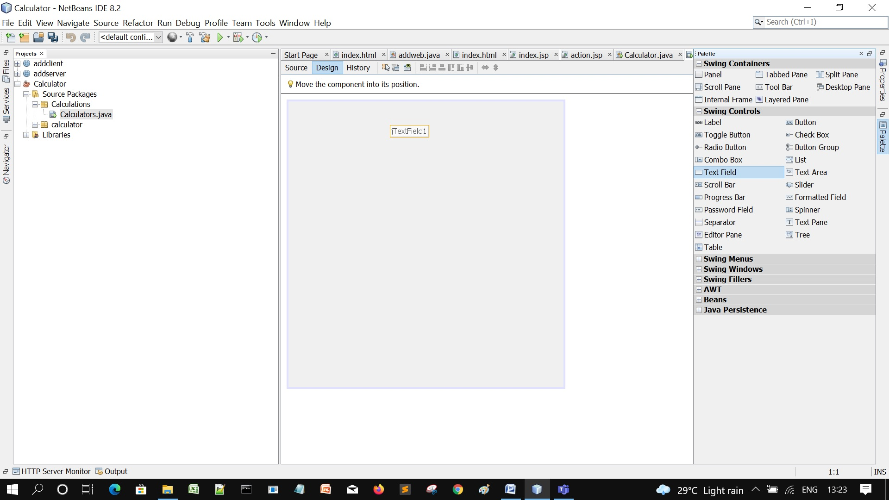

6. Click on the Text Field Properties and Delete the Text content and Adjust Font and HorizontalAlignment as you want.

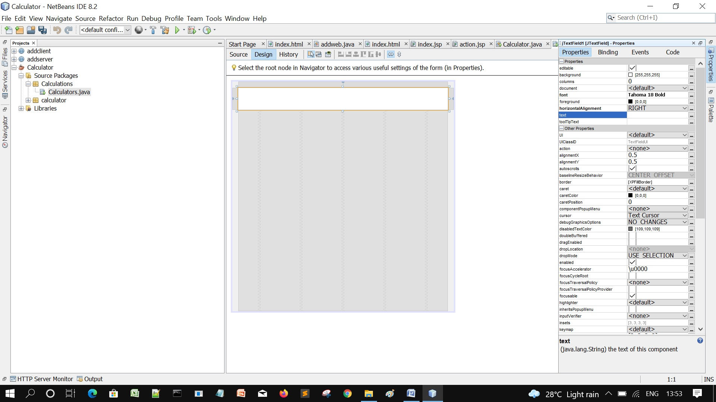

7. In the Palette section, Click on Button and drag towards the design frame

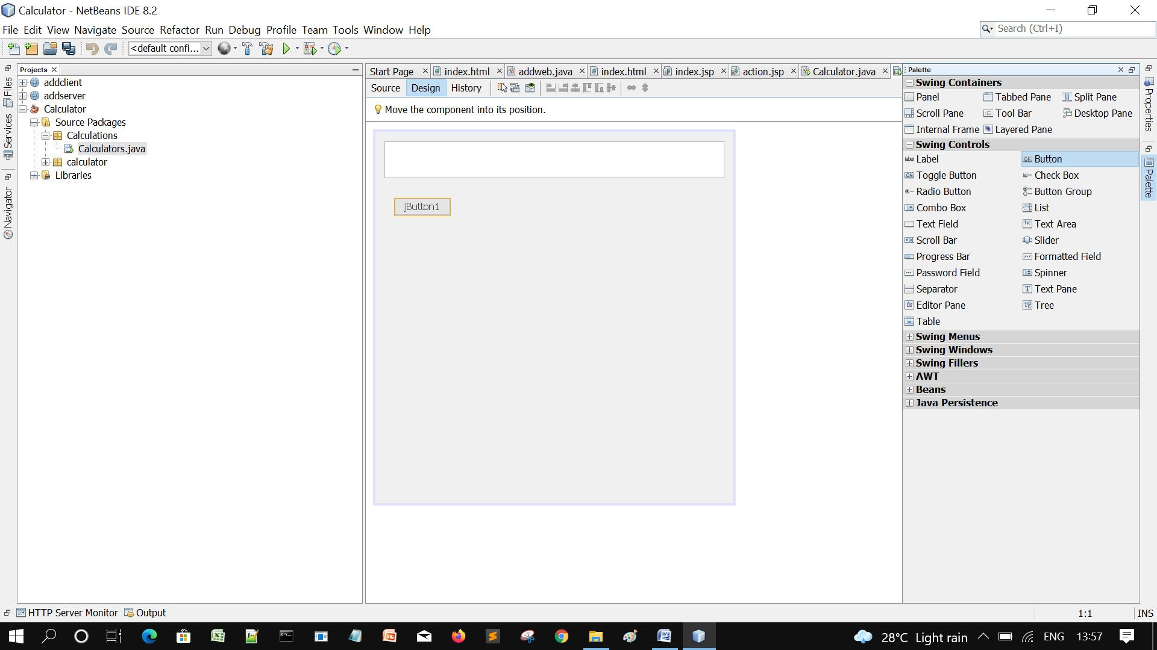

8. Go to the Button Properties (Code section) and change the Variable Name as jBtn1.

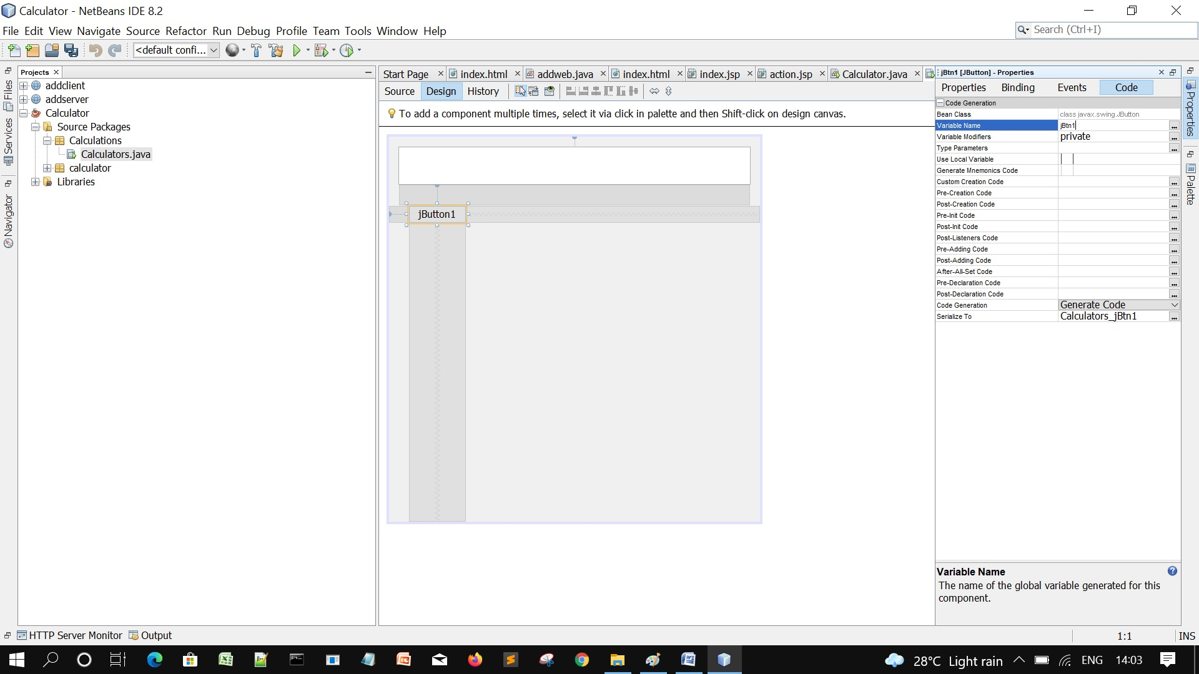

9. Go to the Properties , Delete the Text content, Enter 1 and change the font size as you want.

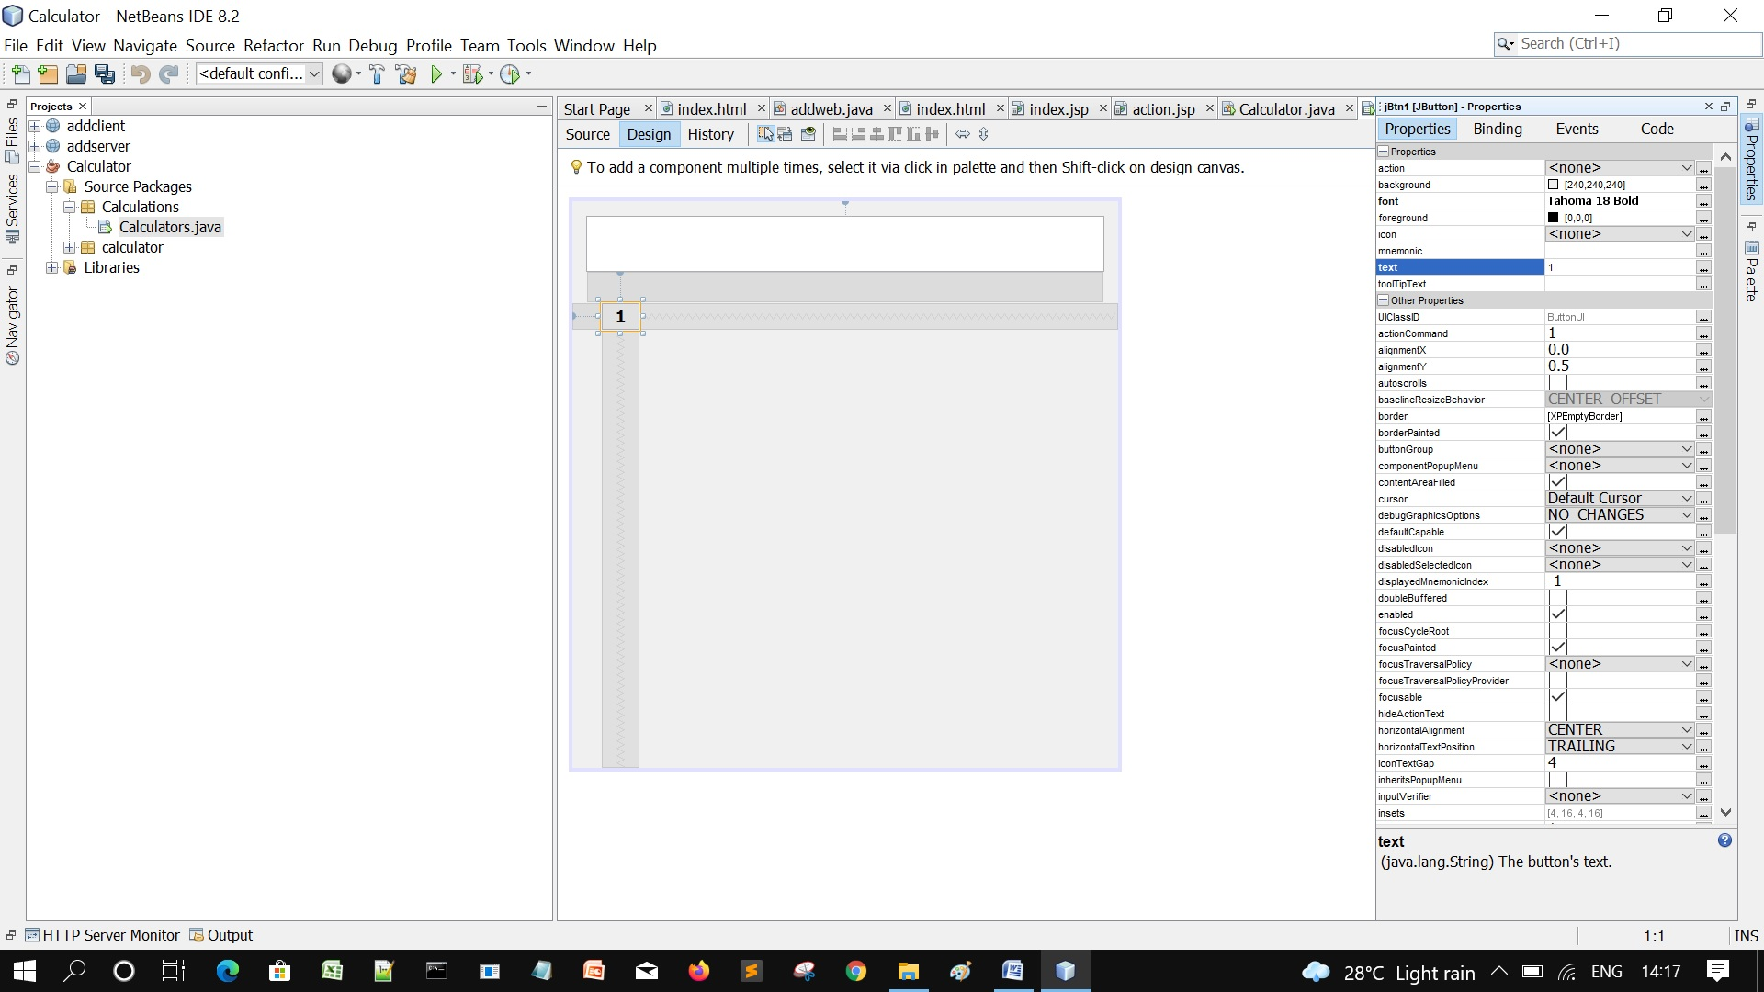

10. Right click on the Button 1, Click Duplicate, new button with different Variable Name will be created.

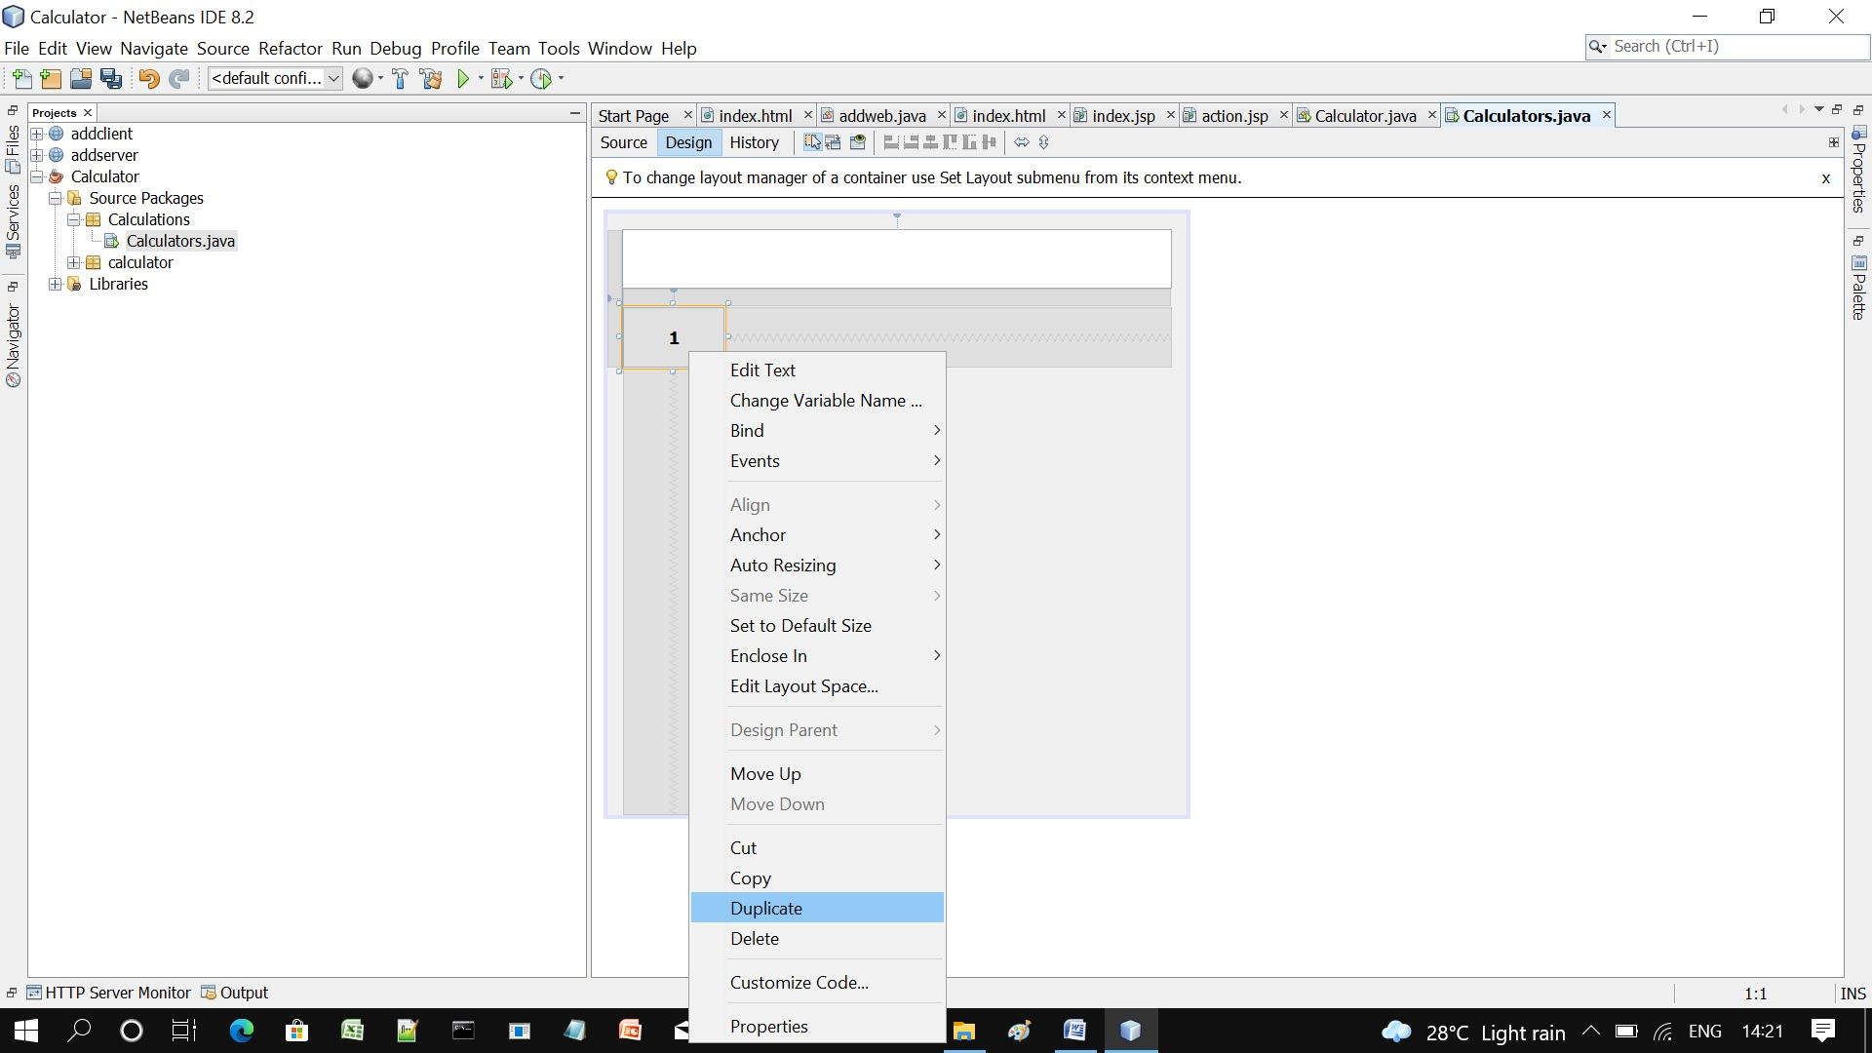

11. Create another buttons and Edit from the Properties (text) as below

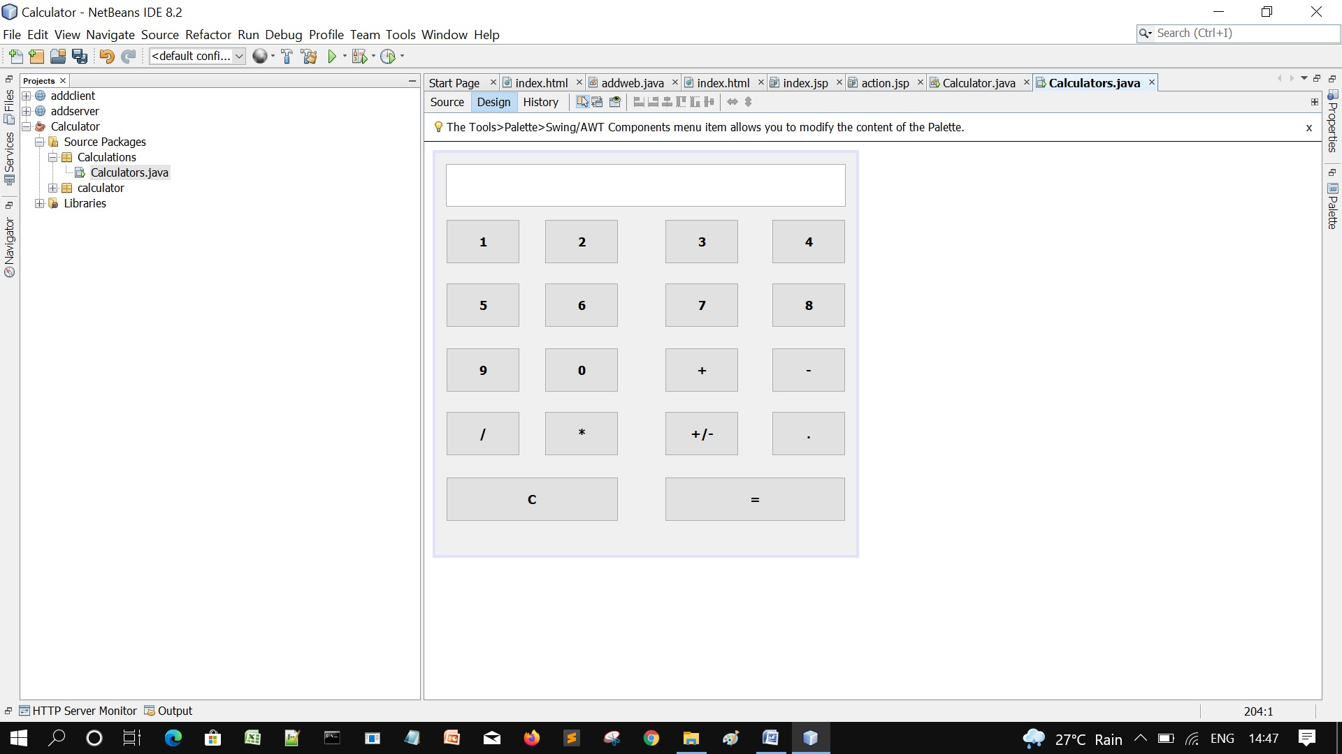

12. Click the Text Field box and change the Variable Name as jtxtDisplay

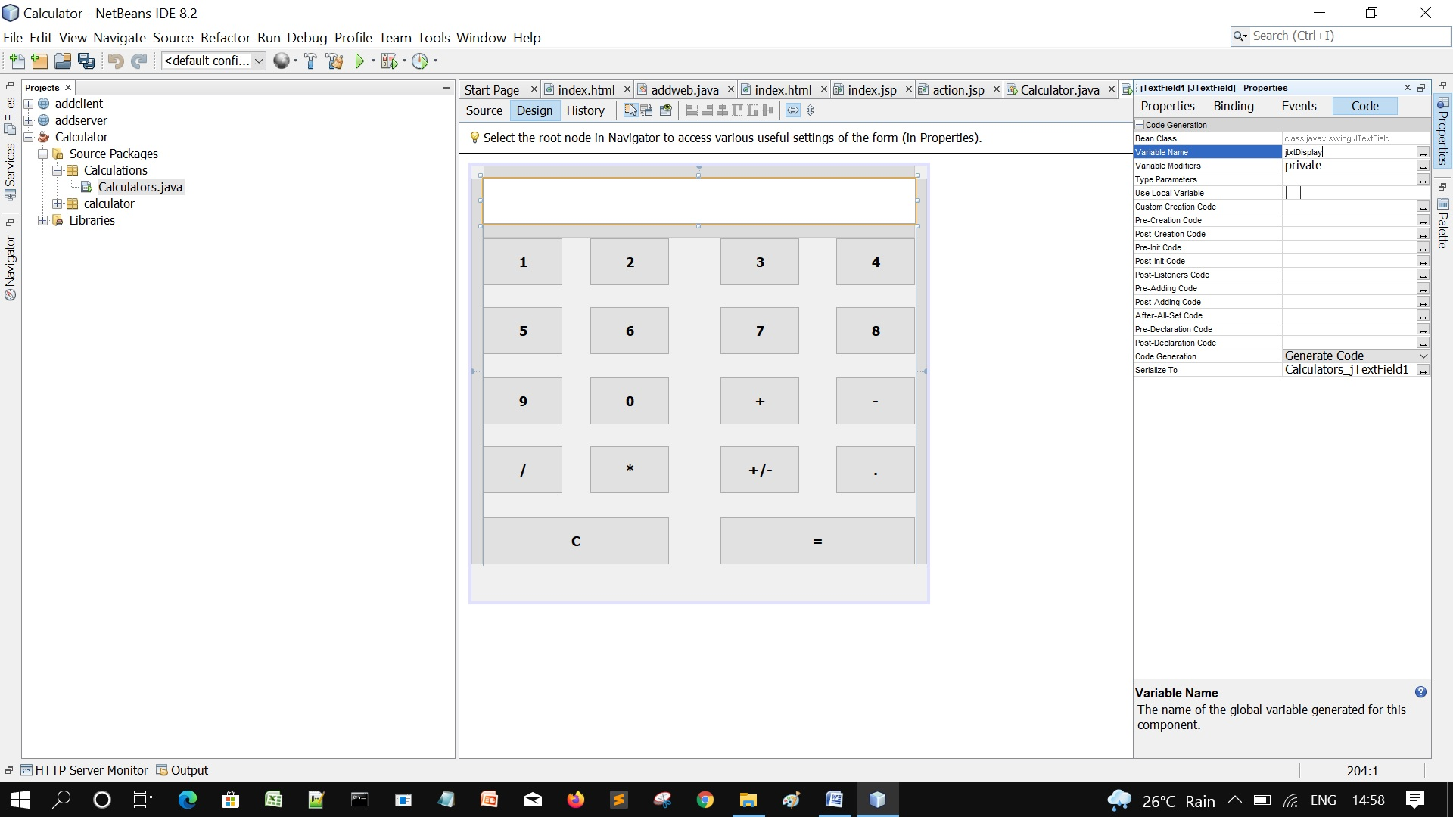

13. Double click on any of the buttons, in the Source code, declare variables as follows

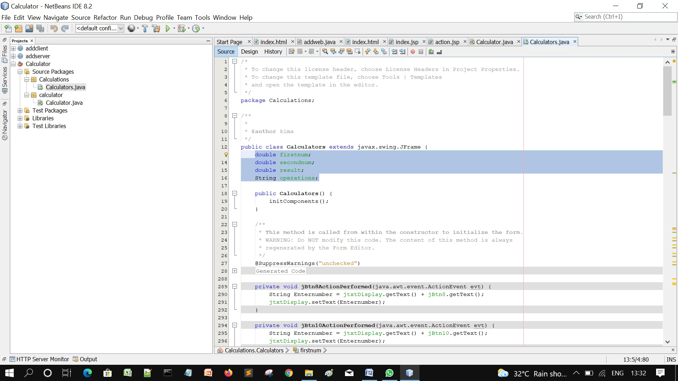

14. Go to the Design view, double click on the first button, enter the following lines of code as follows

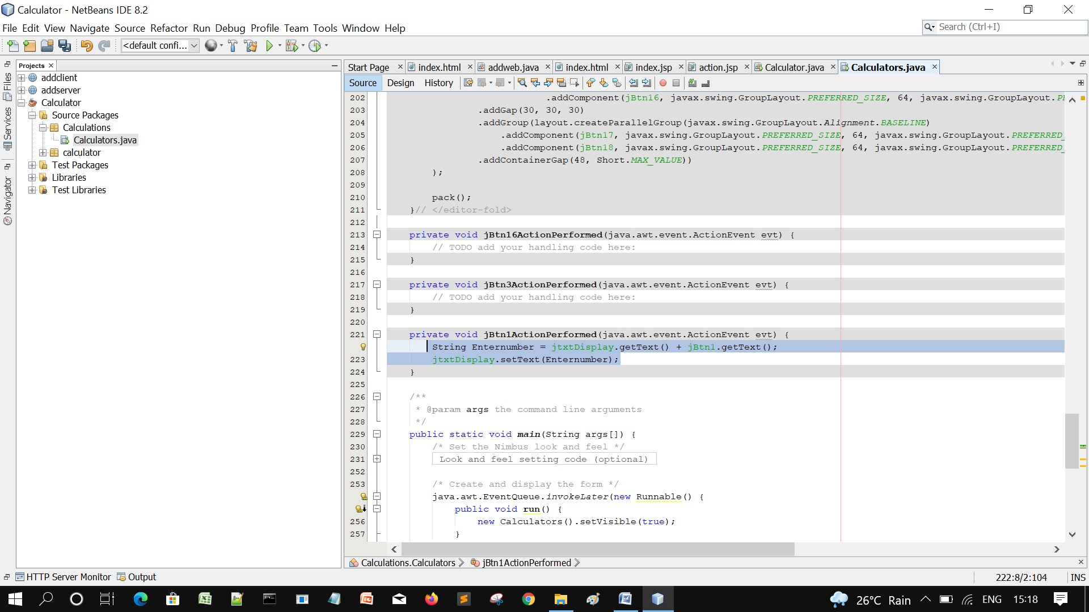

15. Copy the lines of code, go to the Design, double click on button 2, paste it and change the number

And Repeat exactly for buttons 3 to 10.

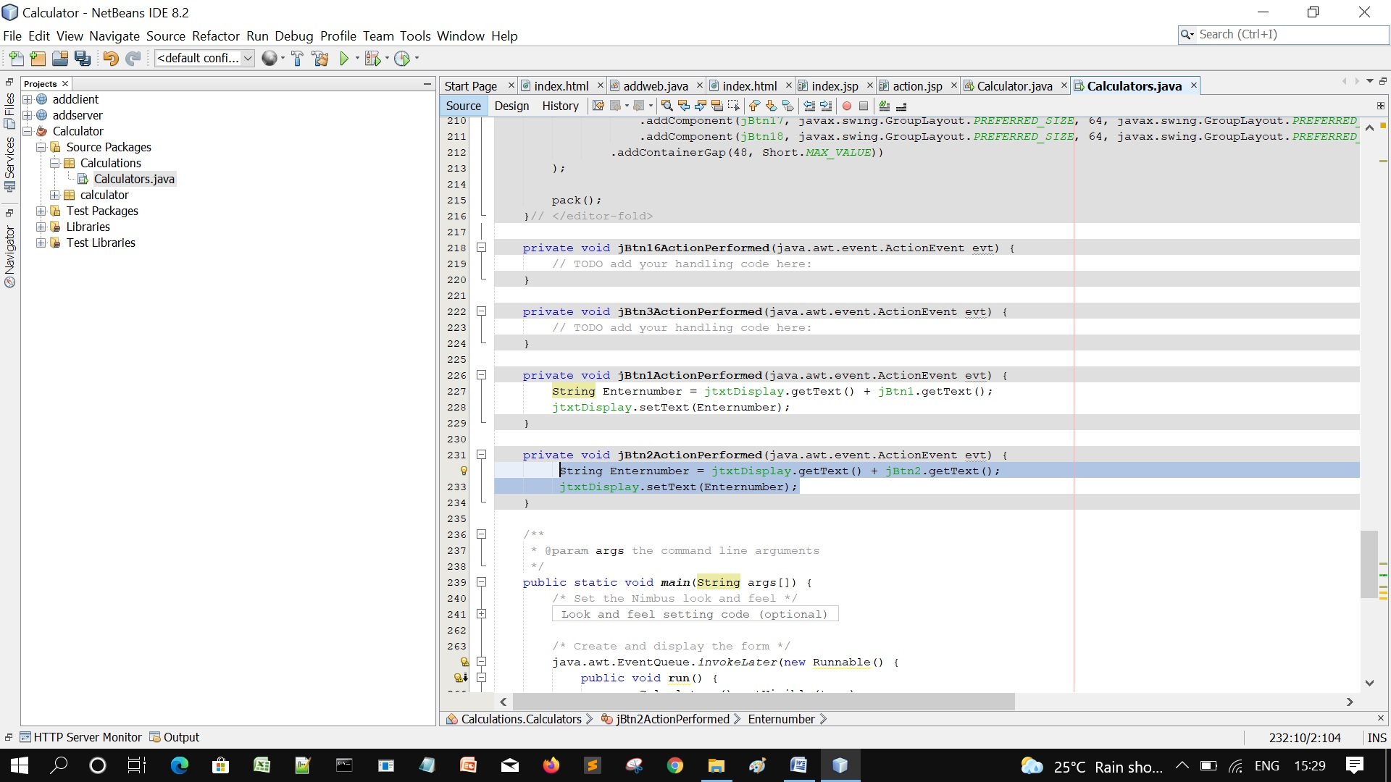

16. For the Clear/Cancel (C) button, enter the lines of code as follows

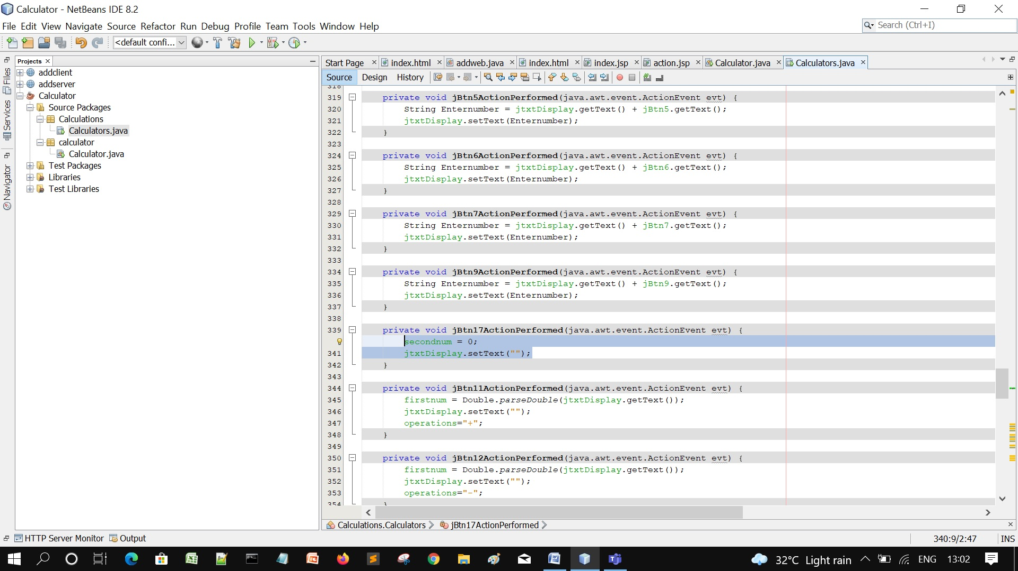

17. Now for the arithmetic operators, double click on the plus button and enter the following code

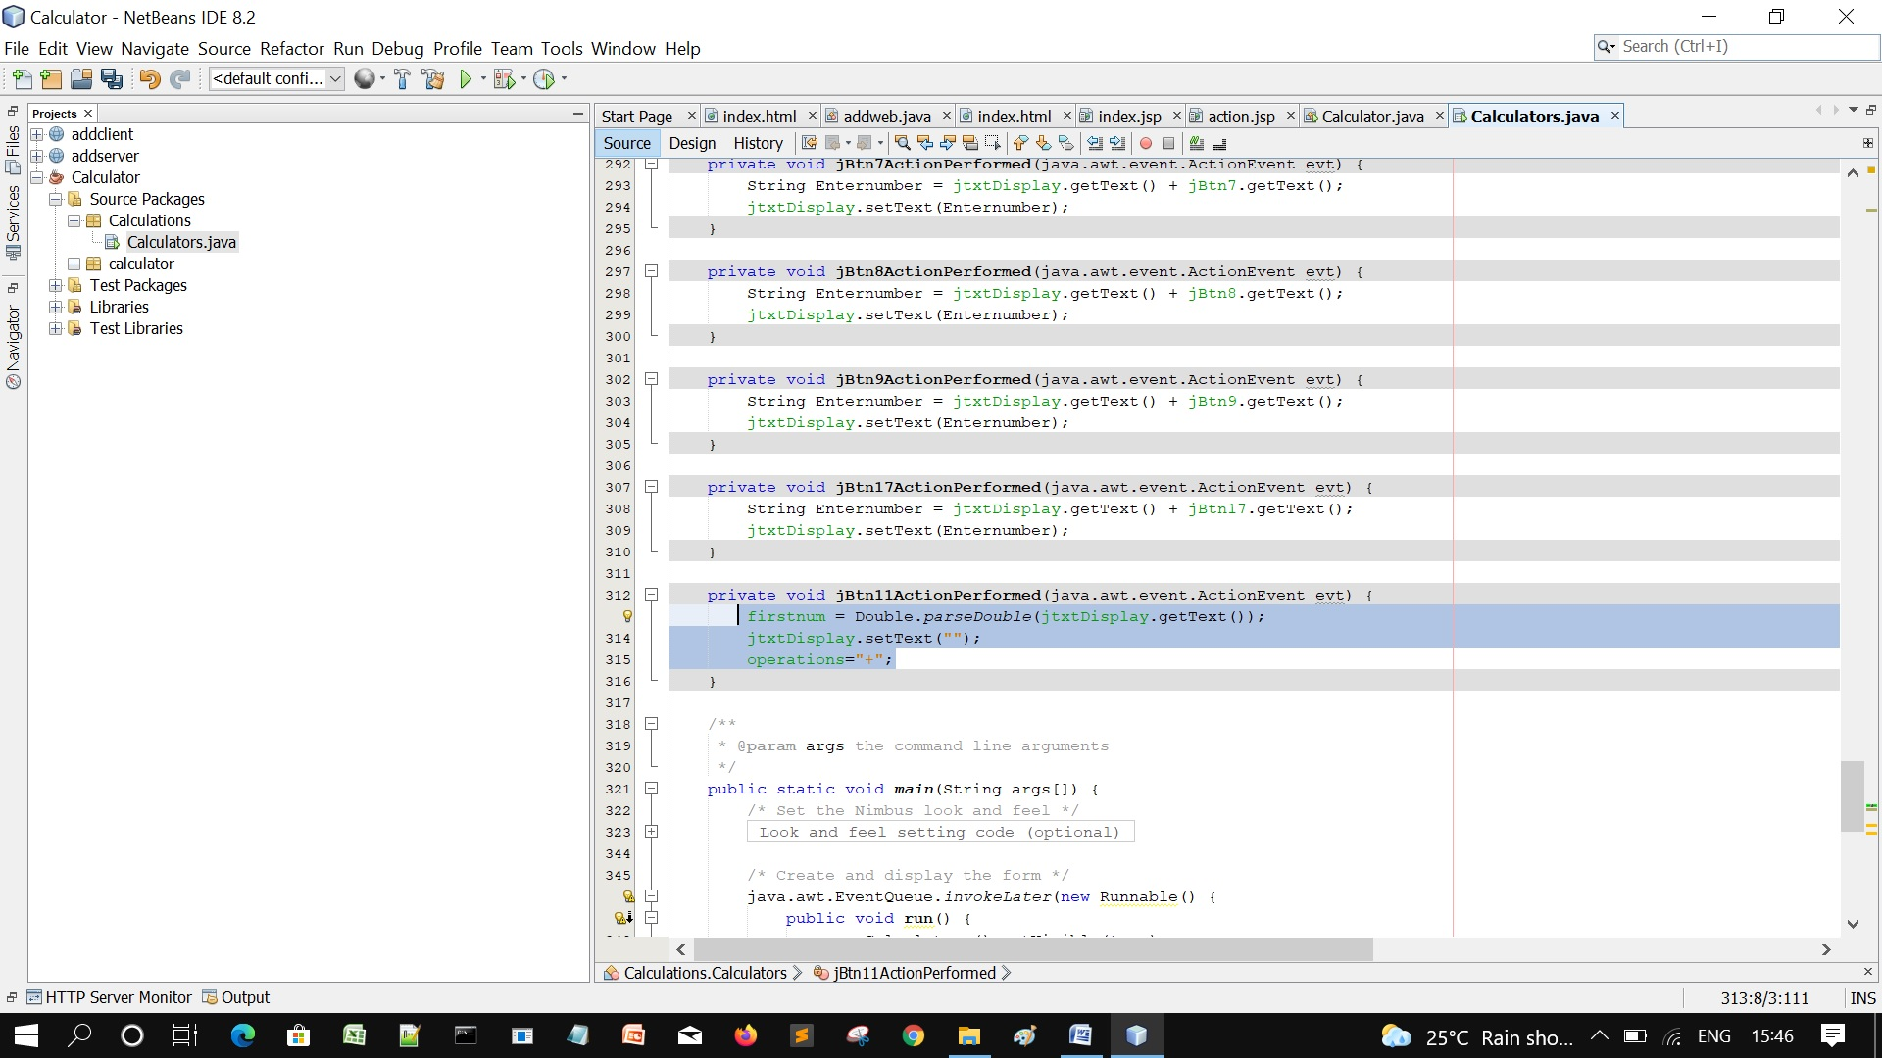

18. Copy the code, go to Design, and do it for Subtraction, Division, and Multiplication by pasting the same code and change the operations respectively.

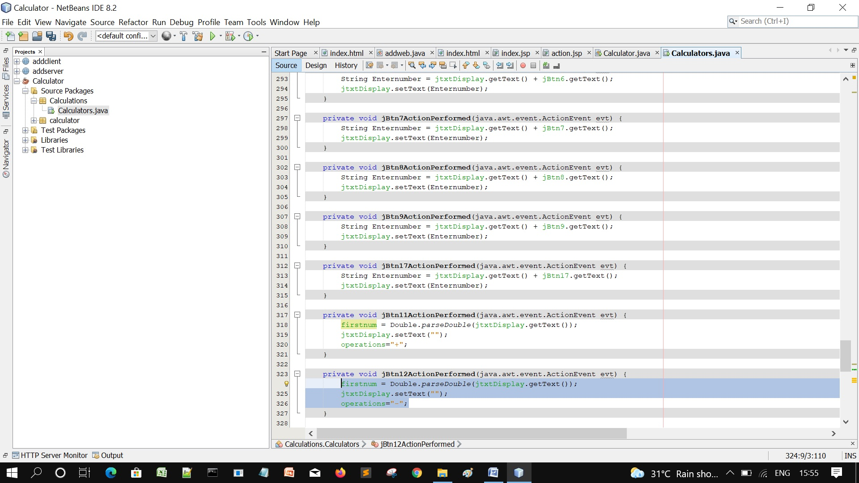

19. For the Full Stop, enter the same code used in buttons 1 to 10

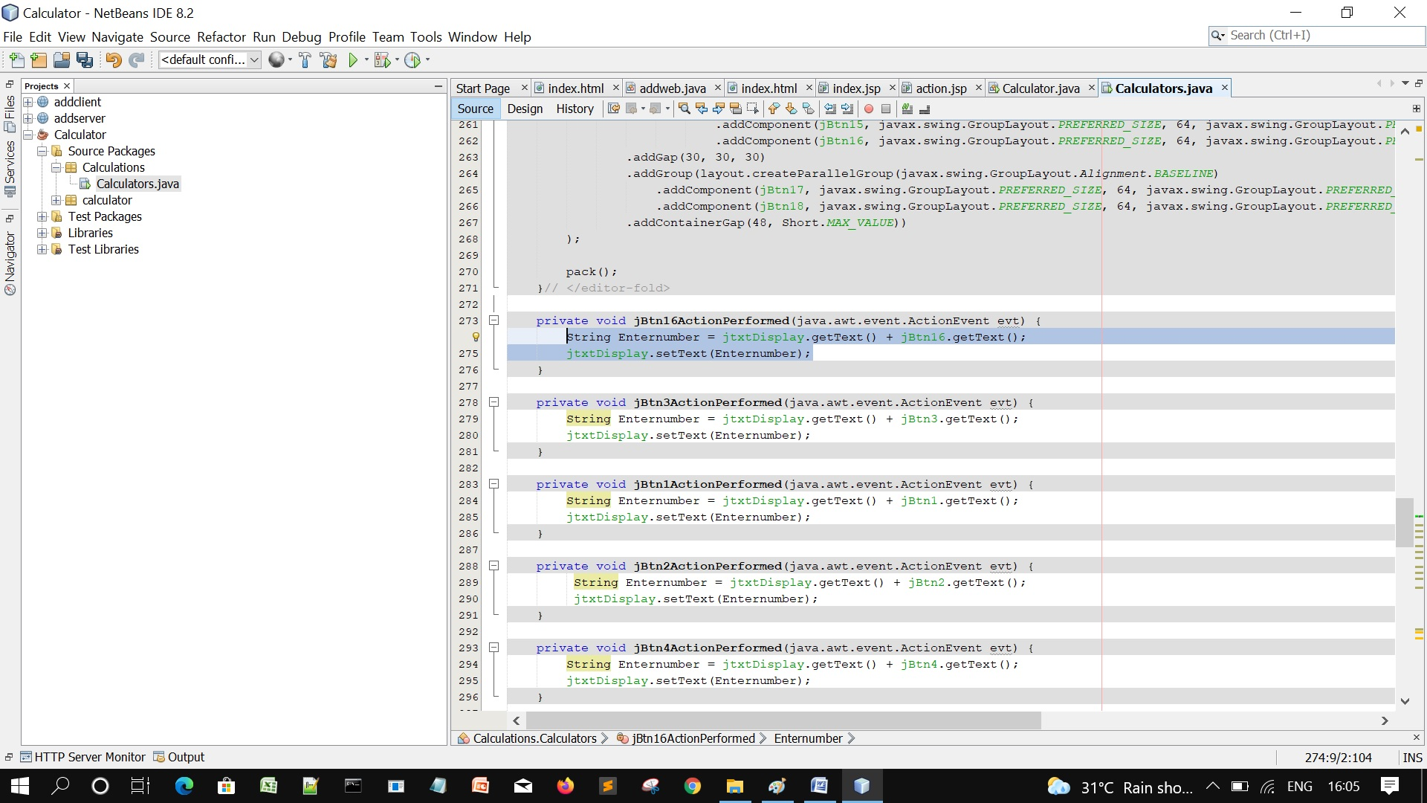

20. Now, for the plus or minus (+/-) , Enter the following lines of code

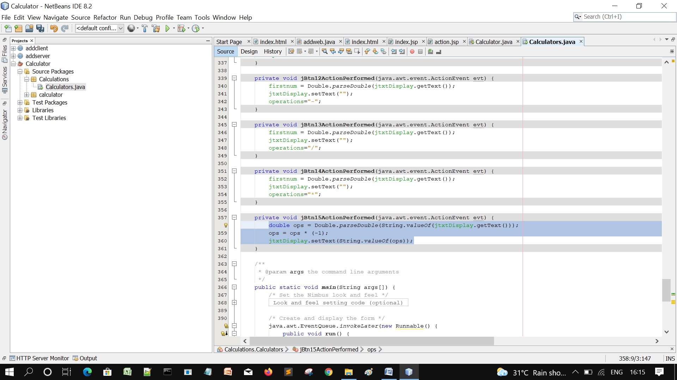

21. For the Equals (=) , enter the following lines of code as shown

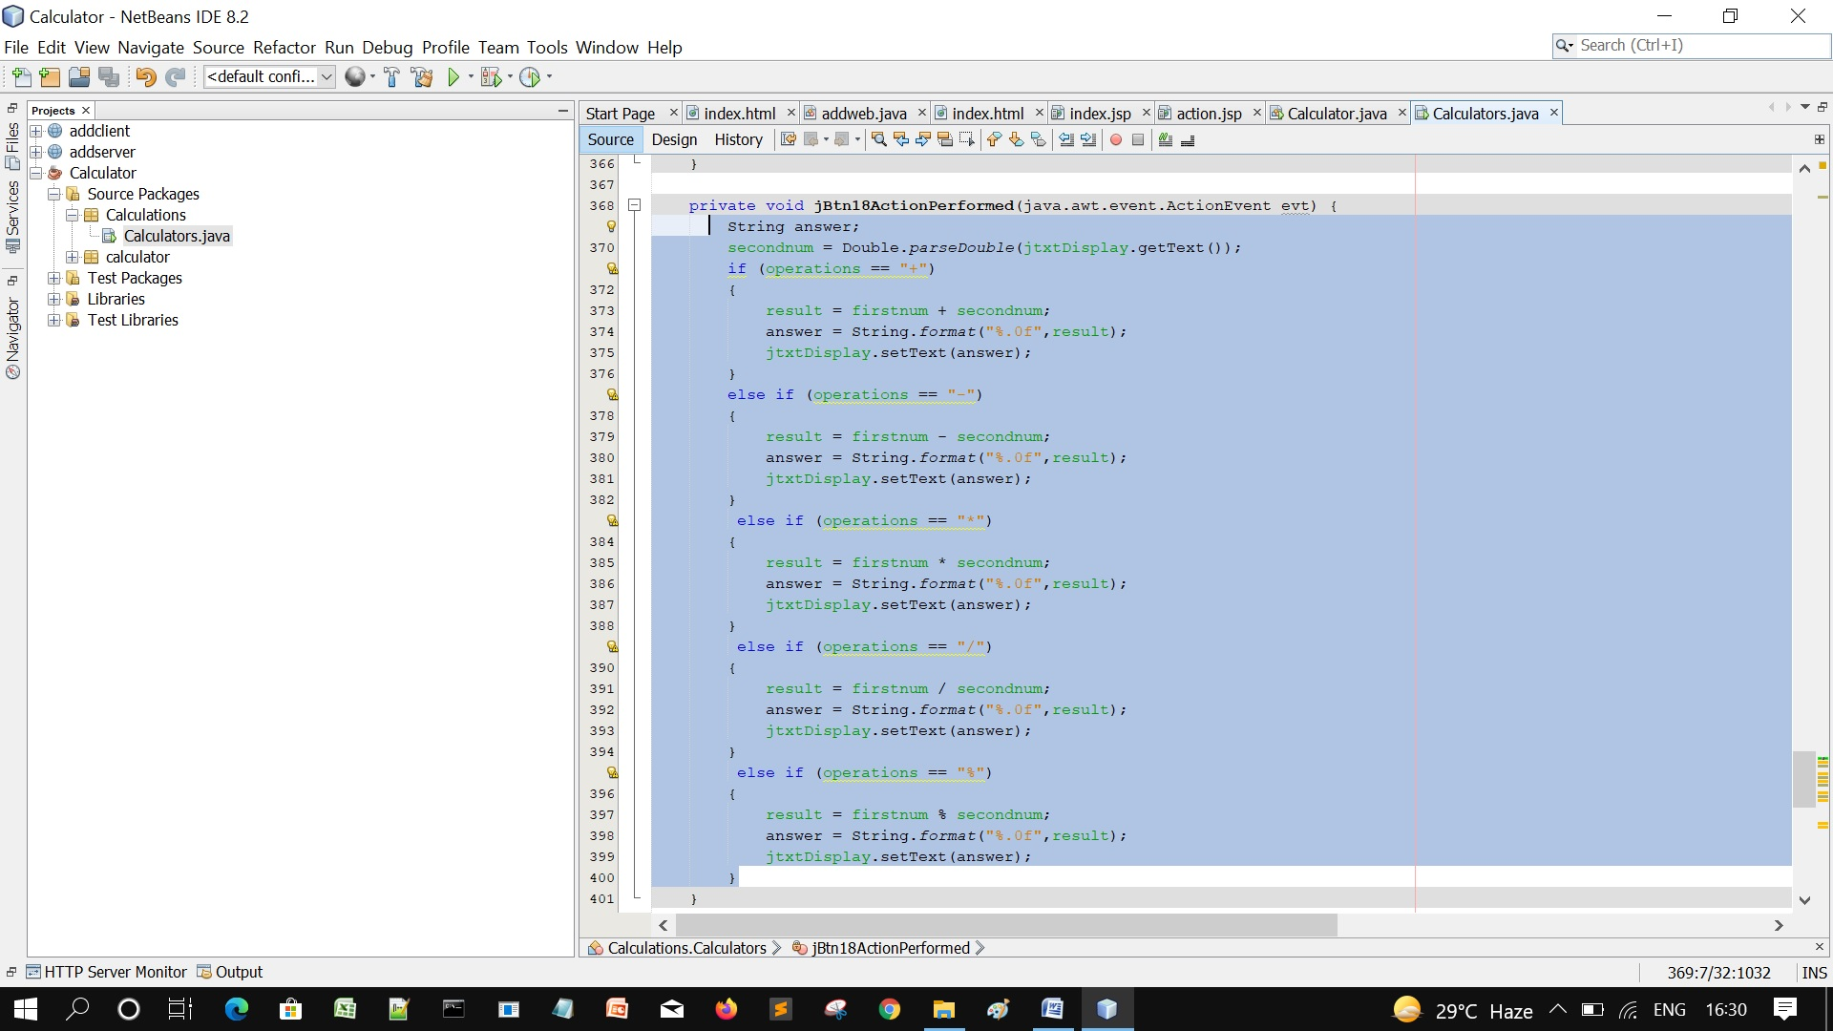

22. Now, run the program

